HouseCall Head and Neck New Patient Questionnaire
Patient Name: ______________________________________________________ DOB: ___________________________
Date of Injury: ________________________ Cause of Injury: ______________________________________
Medications: ___________________________________________________________________________________________________________________________________________________________________________________________________________________________________________________________________________________________________________________________
Allergies: _____________________________________________________________________________________________
My current health is: EXCELLENT GOOD FAIR POOR
My pain/problem area is my: HEAD NECK FACE JAW
Currently working: YES NO Occupation: __________________________________________
Have you had an injury (even in childhood) to any of the following?:
JAW FACE HEAD SHOULDER(S) BACK NECK
-If so, please describe how the past injury occurred:

Please briefly describe your current symptoms:

Symptoms improve with:

Symptoms worsen with:

Please rate your current pain on a scale from 0 (no pain) to 10 (worthy of a trip to the emergency room): 0 1 2 3 4 5 6 7 8 9 10

My symptoms are: IMPROVING STAYING THE SAME WORSENING

When you first noticed your symptoms, had you recently had oral surgery, general surgery, a long dental procedure, or an infection? If so, please explain briefly:

Does your jaw do any of the following?: CLICKING POPPING GRINDING GET STUCK LOCK FEEL PAINFUL FEEL FATIGUED DIFFICULTY OPENING
Do any of the following describe the way you bite?: SENSITIVE OFF CENTER UNCOMFORTABLE HIGH SPOT
Do you wake up with any of the following symptoms?: HEADACHES SORE TEETH SORE FACIAL MUSCLES NECK STIFFNESS SHAKY JAW INABILITY TO FULLY OPEN MOUTH
When do you notice you clench your teeth/jaw?: SLEEPING DAYTIME DRIVING AT WORK PLAYING SPORTS WHILE STRESSED
Do you do any of the following?: CHEW GUM CHEW PENCILS SMOKE BITE YOUR NAILS BITE LIP/CHEEK/TONGUE
Do you have any of the following symptoms in addition to the main problems?:
EAR PAIN RINGING IN EARS DIZZINESS HEARING LOSS FLUID IN EARS FREQUENT EAR INFECTIONS FACIAL NUMBNESS
Are you restless when you sleep?: YES NO Times awakened during night: _____________
What position do you sleep in usually?: ON BACK ON STOMACH ON RIGHT SIDE ON LEFT SIDE ON HAND ON SPOUSE’S ARM
What type of pillows do you use?: FOAM FEATHER CONTOURED CERVICAL ROLL How many do you use? _________________________
While sitting, do you use a lumbar roll or ergonomically correct chair? YES NO
Please list any surgeries you have had, approximate date, and name of physician who performed them: _____________________________________________________________________________________________________________________________________________________________________________________________________________________________________________________________________________________________________________________________________________________________________________________________________________________________________________________________________________________________________________________________________________

Please list any imaging (x-rays, MRI, CT scans) you have had for your condition:
___________________________________________________________________________________________________________________________________________________________________________________________________________________________________________________________________________________________________________________________
Please list all healthcare providers, including credentials (e.g. DDS, DMD, PT, DC, MD) you have seen for this condition:
____________________________________________________________________________________________________________________________________________________________________________________________________________________________________________________________________________________________________________________________________________________________________________________________________________________________________
Mark with an “X” the main areas in which you have pain, and shade areas of general pain.
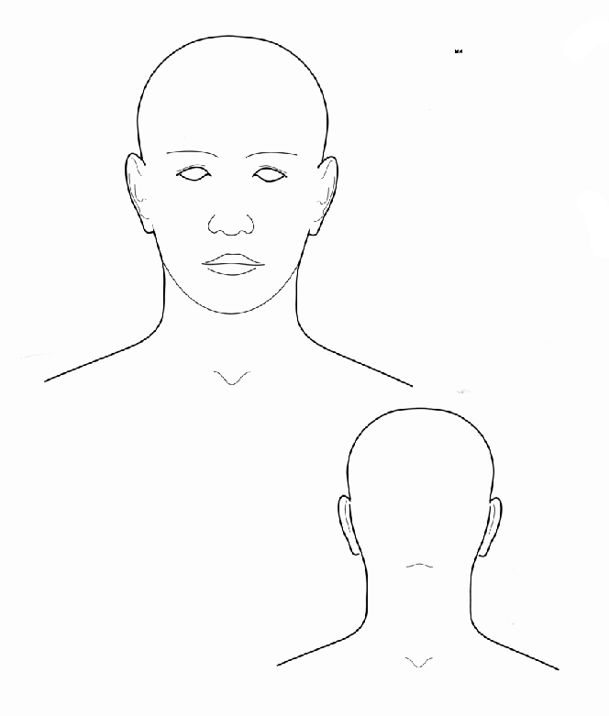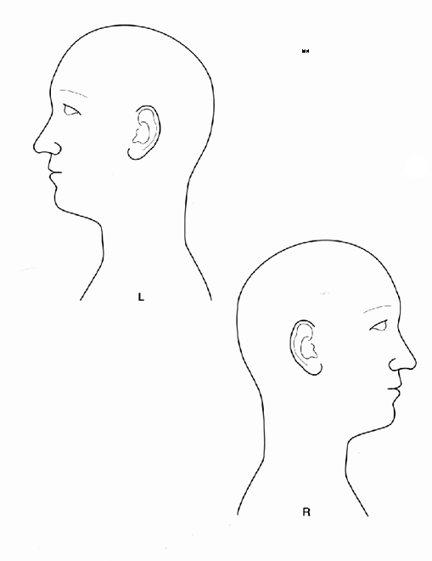
How long does your pain usually last each day?: ________________________________________

Patient/Guardian Signature: _________________________________________________________________

